Komplexübung Volleyball ( )
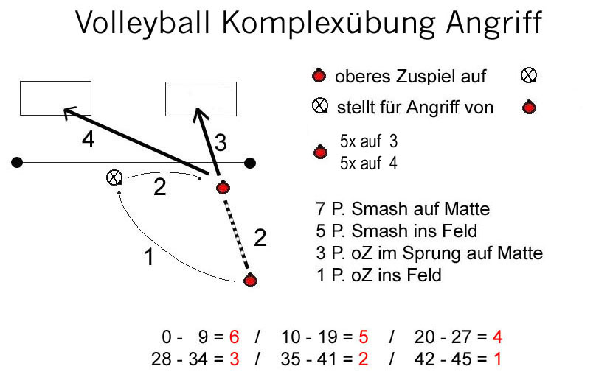

Name | 1 | 2 | 3 | 4 | 5 | P₁ |  | 1 | 2 | 3 | 4 | 5 | P₂ | P | Note

